Дата: 24.11.2022 Клас: 7-А

Предмет: Англійська мова

Тема: Традиційні українські страви.

Мета: формувати навички вживання нових лексичних; вдосконалювати навички читання й мовлення з опорою на лексико-граматичні структури; розвивати мовну здогадку й мовленнєву реакцію учнів; виховувати зацікавленість у розширенні своїх знань.

Вчитель: Глуговська Л.Г.

**Хід уроку**

***1.Greeting***Good afternoon, dear children! I’m glad to see you. Are you ready to start our lesson? Let’s start.

***2. Warming up/Speaking***

*Using the questions below make up your dialogues.*

1. How many brothers / sisters do you have?

2. How many relatives do you have?

3. How much money does gas cost?

4. How many hours do you sleep?

5. How many books do you read in a year?

6. How many close friends do you have?

7. How many hours do you study?

8. How much fruit do you eat?

9. How many vegetables do you have for dinner?

***3. Listening***

*Швидка їжа: за і проти. Улюблена страва. Fast food*

<https://www.youtube.com/watch?v=RAH8DAOolVE>

***4. Crossword.***

Look at the smartboard.  Find the titles of Ukrainian dishes in the crossword.

 (11 words: kutia, holubtsi, uzvar, varenyky, halushky, borshch, pampushky, hrechanyky, kulish, salo, kapusniak)

|  |  |  |  |  |  |  |  |  |  |
| --- | --- | --- | --- | --- | --- | --- | --- | --- | --- |
| W | K | A | P | U | S | N | I | A | K |
| P | M | K | U | L | I | S | H | D | Z |
| A | H | R | Z | L | S | A | B | W | C |
| M | O | Z | V | X | P | R | T | N | M |
| P | L | H | A | L | U | S | H | K | Y |
| U | U | N | R | D | Q | W | A | U | T |
| S | B | O | R | S | C | H | J | T | X |
| H | T | W | F | I | L | O | O | I | T |
| K | S | A | L | O | S | E | Q | A | A |
| Y | I | V | A | R | E | N | Y | K | Y |
| H | R | E | C | H | A | N | Y | K | Y |

***5. Reading***

Прочитайте рецепт борщу.

**BORSCH: CLASSICAL RECIPE**

The first dish of Ukrainian cuisine

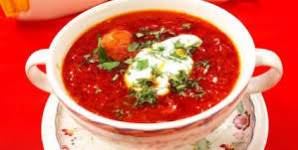**Ingredients:**

**For broth:**

water - 1.5-2 liters;

pork or beef - 400 grams.

**For roasting**:

beets - 2 pieces. (small);

carrots - 1 piece;

onions - 3 pieces. (average);

tomato paste - 2 tablespoons .;

sunflower oil - 4-5 tablespoons .;

**For borsch:**

white cabbage fresh - 300 grams;

potatoes - 5 pieces. (average);

salt, black pepper, bay leaf, greens to taste.

**To submit:**sour cream - 1 tbsp. l. (In each plate);green

**How to cook borsch**

* **Step 1. Cook the broth**

Pour 1.5-2 liters of water into a 3 liter pan. Lay the meat and set over medium heat. Before boiling, remove the foam as soon as the broth boils, cover the pot and simmer for an hour and a half.

* **Step 2. Make the fry**

We wash and clean beets, carrots and onions. Grind the beets on a large grater and the carrots on a medium grater. Cut the onion into cubes.

On a medium heat in a frying pan heat the oil, pour onions and carrots there, fry for 5 minutes. Add the beets.

Fry the vegetables for another 5 minutes, add the tomato paste, stir and fry for another 5-7 minutes.

* **Step 3. Boil borsch**

Remove the meat from the broth and toss the shredded cabbage into the broth until cool. After 5-10 minutes, add the chopped potatoes. Separate the meat from the bone and dice. Turn the meat into borsch, salt it and add the roast. Mix the borscht, put the bay leaf and finely chopped greens, cover and cook for another 5-7 minutes.

Borsch is ready! Serve borsch with sour cream, garlic pampushkas and greens.

***6. Writing***

***Write your own recipe dish. The length of the text is 6-8 sentences.***

Напишіть власний рецепт страви. Обсяг тексту 6-8 речень.

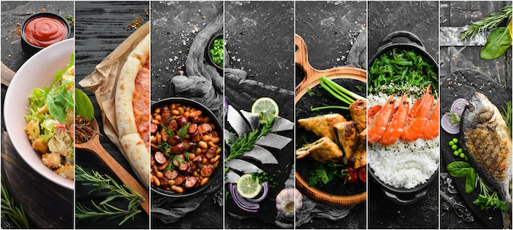

***7. Homework***

1. Опрацюйте конспект уроку;

2. Напишіть власний рецепт страви. Обсяг тексту 6-8 речень.

**Надіслати виконане завдання у Вайбер/телеграм (0964124047) – Людмила Григорівна або на Human.**